

Software design and architecture

Lab Report # 08



date: 16-12-2021

HAJRA MUQDDSA AKBAR-12319

MAHEEN NASIR-12315

BSSE—4B

Submitted to: ma’am Saadia shabir

**Question no. 1:**

Draw a sequence diagram with the following scenario statements

* + Firstly, the application is opened by the user.
  + The device then gets access to the web cam.
  + The webcam captures the image of the user.
  + The device uses algorithms to detect the face and predict the mood.
  + It then requests database for dictionary of possible moods.
  + The mood is retrieved from the database.
  + The mood is displayed to the user.
  + The music is requested from the database.
  + The playlist is generated and finally shown to the user.

**Diagram:**

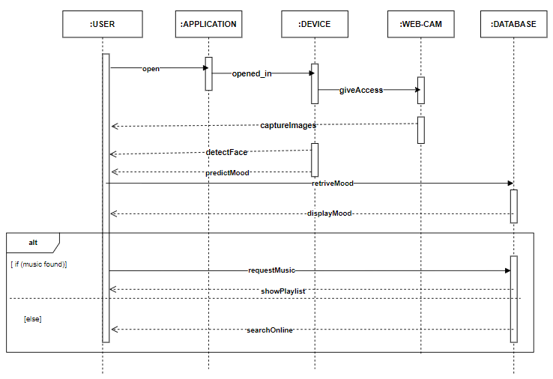

**Question no.2:**

Draw a sequence diagram for following scenario

* A student would like to book a laboratory session slot for his/her practical class. The scheduler will check for a free slot. If there is a free slot, the student will be accepted. The student will be assigned to a specific slot in the schedule. The student will be notified with a confirmation message. If there is no free slot available in the system, a message will be prepared by the scheduler and the notification will be sent to the student. The initial message login will be originated from the user interface and send to the scheduler.

**Diagram:**

